Walkthrough 18 Icons

<https://sapui5.hana.ondemand.com/#/topic/776f7352807e4f82b18176c8fbdc0c56>

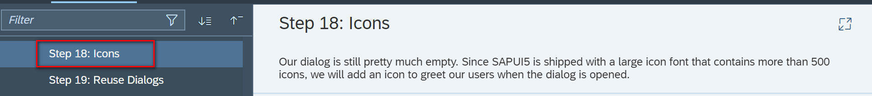

Core Changed Codes Compared to Last Version:

HelloPanel.view.xml【Update】

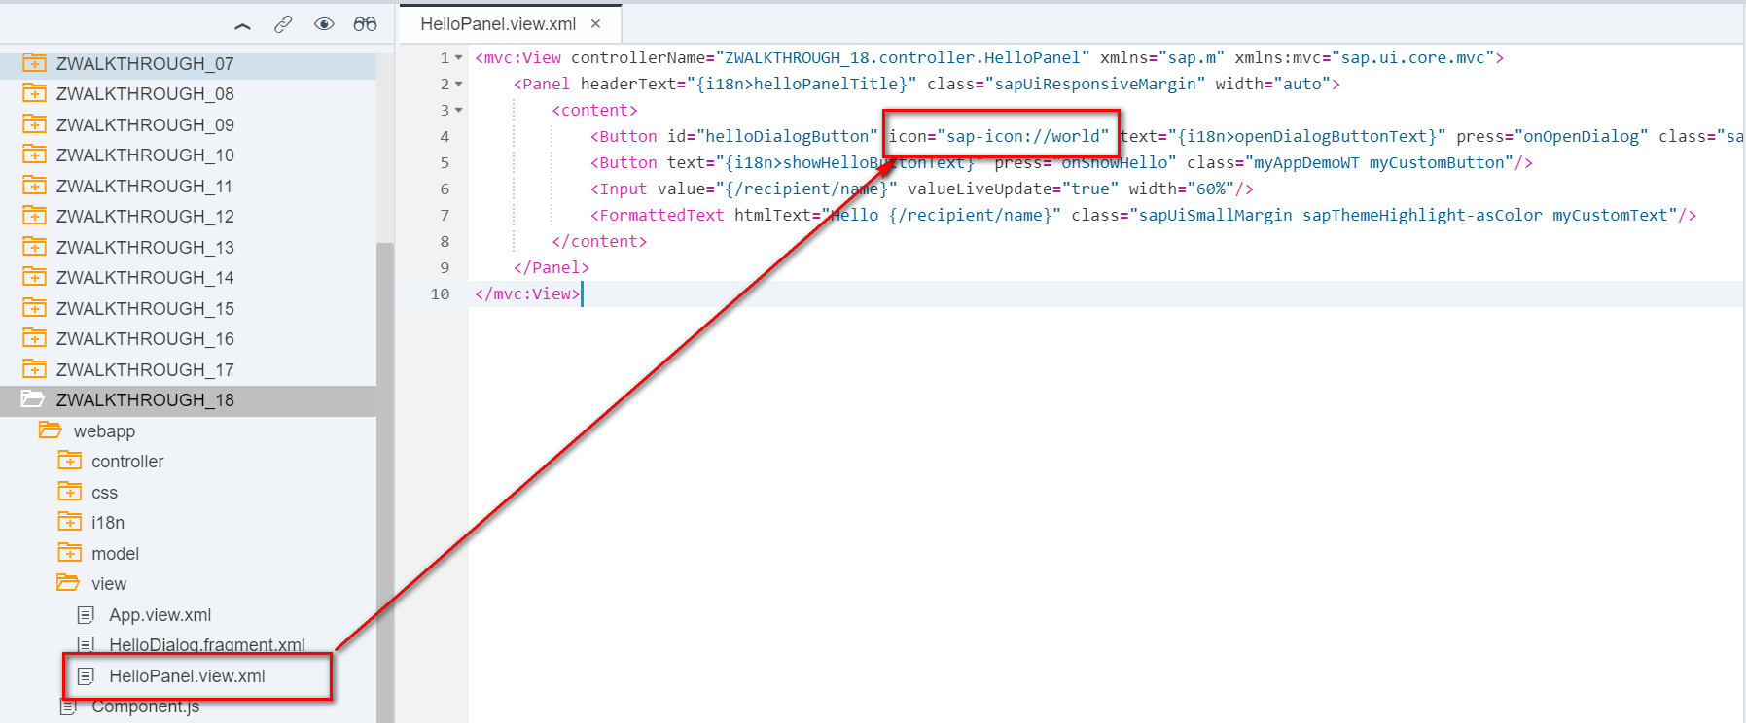

HelloDialog.fragment.xml【Update】

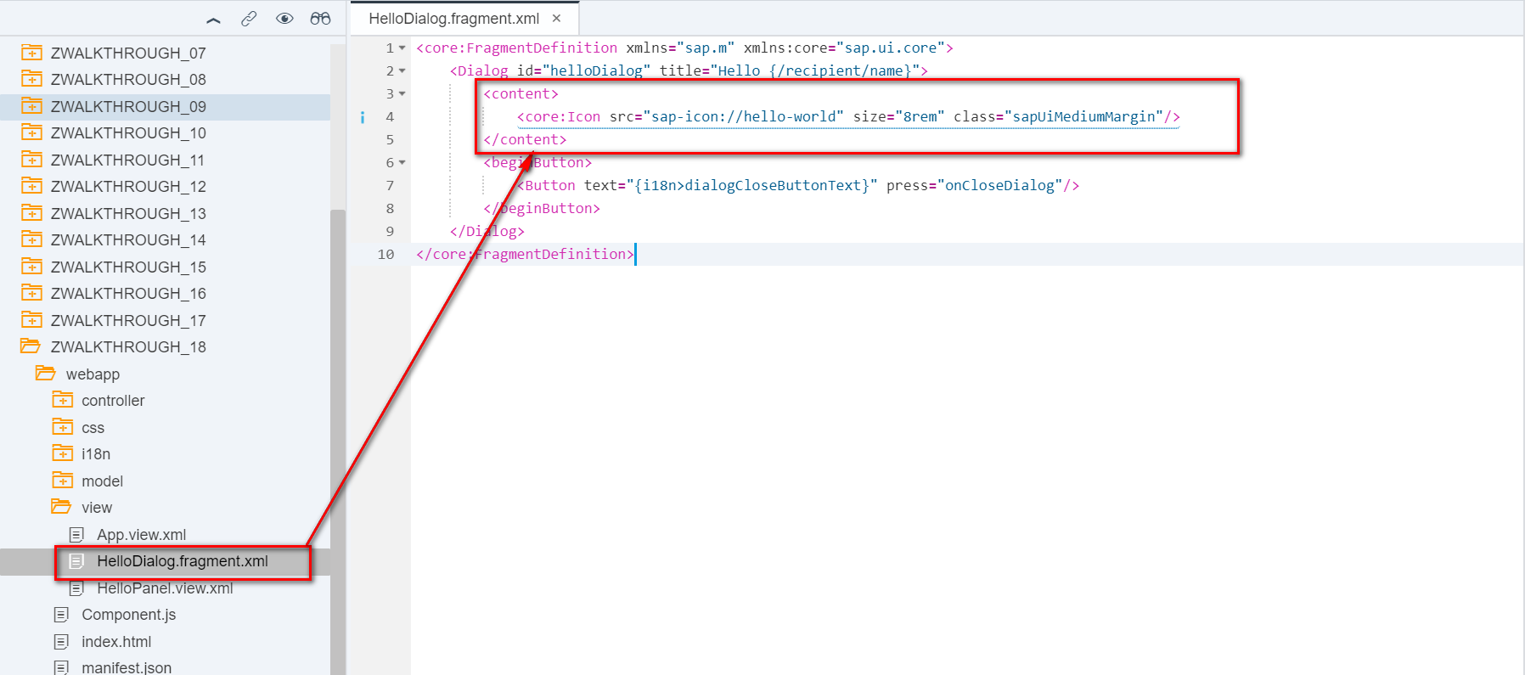

Result:

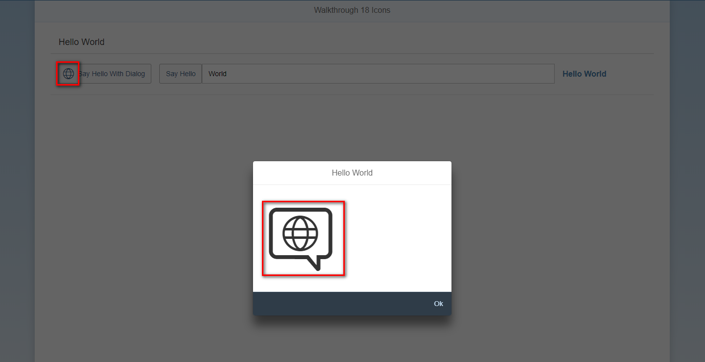

Git:

https://github.com/xiexiaop/SAPUI5-2-Round/tree/master/Projects/ZWALKTHROUGH_18

2019/01/25 XiaoMi Beijing Zac,Xie